**Product Design**

|  |  |
| --- | --- |
| **Team** | f610-01c **Team members**: Ibrahim Mujhid,  Pooja Apparao Raghoji,  Raghuram Gopalkrishnan,  Rahul Kumar shinde,  Rohan Kerkar. |
|  |  |
|  |  |
|  |  |
|  |  |

# Architectural Overview

# 

**Database Design**

# 

# Components and Functions

|  |  |
| --- | --- |
| Registration | The component is responsible for registering new users.  The subsystem stores details of new successfully registered users. It uses these details for future authentication of the registered users. |
| Login | The component is responsible for authenticating registered users.  The subsystem allows successfully logged in users to have access to the tool share system. |
| Account Management | The component is responsible for allowing users to modify account details.  The subsystem allows to change personal information and also to modify user preferences. |
| Shed Creation | The component is responsible for creation of shed/s for a particular share zone.  The subsystem allows the registered users to create shed for sharing tools. A shed is a physical location from where tools can be stored and shared. And also the shed creator becomes the shed coordinator. |
| Tool Management | The component is responsible for tool registration and activities related to tool management.  The subsystem allows the registered users to: Register a tool, Modify tool status, List tools and to activate and deactivate a tool. |
| Tool Sharing | The component is responsible for sharing of tool with the borrower.  The subsystem allows the user to: Set previously registered tool to be shared from home or from community shed,  User can change tool location, Change availability of tool. |
| Tool Borrowing | The component is responsible for allowing users to borrow and handling the activities corresponding to borrow.  The subsystem allows the user to request tool, to make borrow arrangements and then return the tool to the owner or to the shed. Also the activities pertaining to approval or rejection of borrow request is handled by this subsystem. |
| Community Statistics | The component is responsible for allowing user to access statistics of a share zone.  The subsystem allows the user access the statistics like most active lender, most active borrower, most used tools, most recently-used tools. |

# Class Diagram(s)

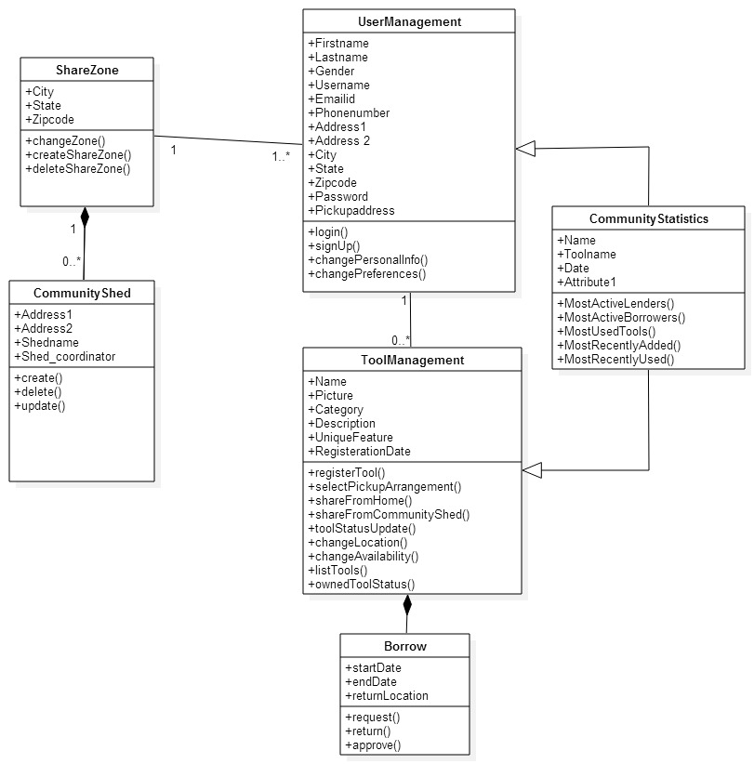

# Sequence Diagram(s)

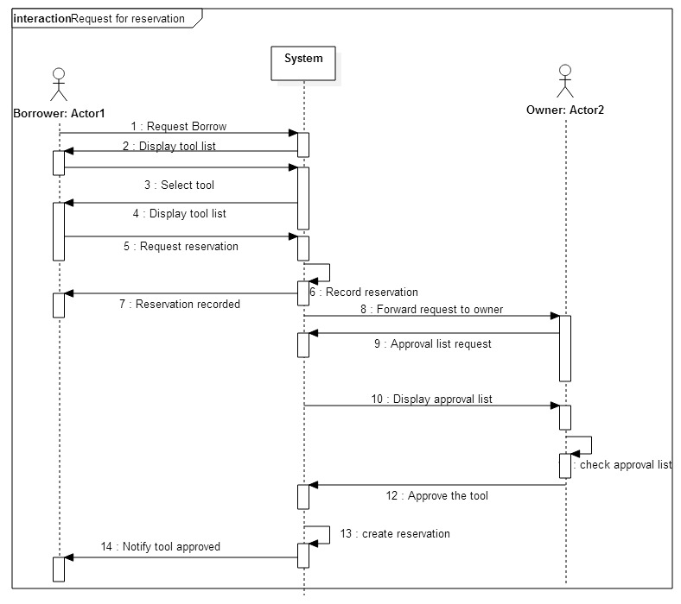

# Design Rationale

1. **Tool for Uml Diagrams:** We had a prolonged discussion of the tool we would use for constructing the Uml Diagrams. We narrowed our choices down to ‘Star UML’, ‘Visual paradigm’, ‘Argo UML’. We then selected ‘Star UML’ to construct UML diagrams for ease of using tools and editing our diagrams in Star Uml.
2. **Database:** We decided on using the database ‘sqlite’ which is inbuilt in python. The reason for this decision was that we would be able to develop the application faster by using the inbuilt database.The database table names and attributes were initially confusing and redundant. We have tried to reduce redundancy by normalizing the tables that we created initially.
3. **Class Diagrams:** To follow the divide and conquer strategy, we made multiple classes such as toolListing, changeLocation, sharefromhome, sharefromcommunityshed. But we realized that these can be functions in the Tool Management class that we have created. So we included them under one class, as the User will use all these functions under Tool management in the project.
4. **Names of Classes: Naming Convention:** The names of the classes while constructing the class diagrams initially were not specific to the classes that we needed to implement. We changed the names of classes to specific names so that we get a better understanding of what our classes do. Similarly we changed some of our data members and member function names to specific names for better understanding.
5. **Sequence Diagram:** The sequence diagram of ‘Request for reservation of tool’ was initially an overview of how objects interact in time sequence. We discussed the use cases related to the reservation of tool in detail and noted the actions we need to consider from the systems point of you as well as the user owner and borrowers point of view. We then modified our sequence diagram to show a better control flow with respect to what the actors and lifeline would do.